Class : XII WORKSHEET NO.3
Subject: CHEMISTRY
1. For the reaction: 2A + B → A₂B the rate = k[A][B]² with k = 2.0 × 10⁻⁶ mol⁻² L ² s ⁻¹ .
a. Calculate the initial rate of the reaction when [A] = 0.1 mol L⁻¹, [B] =
0.2 mol L⁻¹.
b. Calculate the rate of reaction after [A] is reduced to 0.06 mol L⁻¹.
2. The decomposition of NH₃ on platinum surface is zero order reaction.
What are the rates of production of N₂ and H₂ if k = 2.5 × 10⁻⁴ mol⁻¹ L s⁻¹?
3. A reaction is second order with respect to a reactant. How is the rate of reaction affected if the concentration of the reactant is (i) doubled (ii) reduced to half?
4. What is the effect of temperature on the rate constant of a reaction?
How can this temperature effect on rate constant be represented quantitatively?
5. Calculate the half-life of a first order reaction from their rate constants given below:
(a) 200 s⁻¹ (b) 2 min⁻¹

6. In a pseudo first order hydrolysis of ester in water, the following results were obtained:
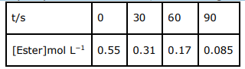
(a) Calculate the average rate of reaction between the time intervals 30 to 60 seconds.
(b) Calculate the pseudo first order rate constant for the hydrolysis of ester.
7. In a reaction between A and B, the initial rate of reaction (r₀) was measured for
different initial concentrations of A and B as given below:
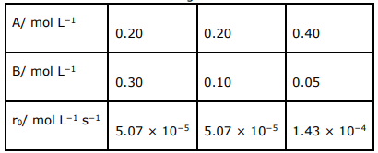
What is the order of the reaction with respect to A and B?
8. From the rate expression for the following reactions, determine their order of reaction and the dimensions of the rate constants. (i) 3 NO(g) → N₂O (g)
Rate = k[NO]₂ (ii) H₂O₂ _{(aq)} + 3 I⁻ _{(aq)} + 2 H+ → 2 H2O (l) + Rate = k[H₂O₂][I⁻]
9. A reaction is first order in A and second order in B. (i) Write the differential rate equation. (ii) How is the rate affected on increasing the concentration of B three times? (iii) How is the rate affected when the concentrations of both A and B are doubled?
10. The experimental data for decomposition of N₂O₅ in gas phase at 318K are given below:
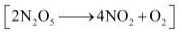

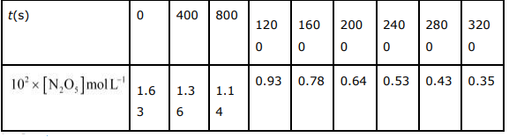
(i) Plot [N2O5] against t.
(ii) Find the half-life period for the reaction.
(iii) Draw a graph between log [N₂O₅] and t.
(iv) What is the rate law?
(v) Calculate the rate constant.
(vi) Calculate the half-life period from k and compare it with (ii).
11. The rate constant for a first order reaction is 60 s−1. How much time will it take to reduce the initial concentration of the reactant to its 1/16th value?
12. During nuclear explosion, one of the products is 90Sr with half-life of 28.1 years. If 1µg of 90Sr was absorbed in the bones of a newly born baby instead of calcium, how much of it will remain after 10 years and 60 years if it is not lost metabolically.
12. For a first order reaction, show that time required for 99% completion is twice the time required for the completion of 90% of reaction.
13. A first order reaction takes 40 min for 30% decomposition. Calculate t1/2.
14. The rate constant for the decomposition of N2O5 at various temperatures is given below:
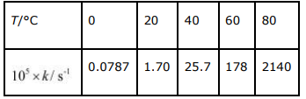
Draw a graph between ln k and 1/T and calculate the values of A and Ea. Predict the rate constant at 30º and 50ºC.
15. The rate constant for the decomposition of hydrocarbons is 2.418 × 10−5 s −1 at 546 K. If the energy of activation is 179.9 kJ/mol, what will be the value of pre-exponential factor?
16. Consider a certain reaction A → Products with k = 2.0 × 10−2 s −1. Calculate the concentration of A remaining after 100 s if the initial concentration of A is 1.0 mol L⁻¹.
17. Sucrose decomposes in acid solution into glucose and fructose according to the first order rate law, with t_{1/2} = 3.00 hours. What fraction of sample of sucrose remains after 8 hours?
18. The decomposition of hydrocarbon follows the equation k = (4.5 × 1011 s−1) e−28000 K/T Calculate Ea.
19. The rate constant for the first order decomposition of H2O2 is given by the following equation: log k = 14.34 − 1.25 × 104 K/T Calculate Ea for this reaction and at what temperature will its half-period be 256 minutes?
20. The decomposition of A into product has value of k as 4.5 × 103 s −1 at 10°C and energy of activation 60 kJ mol−1 . At what temperature would k be 1.5 × 104 s −1?

